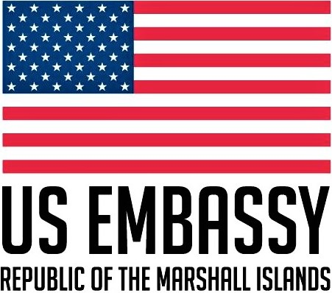

Public Affairs Section
P.O. Box 1379
Majuro, Republic of the Marshall Islands, MH 96960

Telephone: (692) 247 4011

Email: MajuroPublic@State.Gov

The U.S. Embassy in Majuro is proud to support the work of Non -Governmental Organizations within the Republic of the Marshall Islands.

The Embassy periodically advertises grant opportunities which it feels would be of use to NGOs operating in the RMI. Opportunities in the past have included various grants covering many different areas relevant to the Marshall Islands.

In an effort to aid RMI grant applicants in the application process these guidelines have been created to help new and experienced potential grantees as they create project proposals.

In applying for a grant it can be of use to have some background information on what a grant is and some of the regulations and rules have a role to play in the process.

What is a Grant?
Grants are not benefits or entitlements. A U.S. federal grant is an award of financial assistance from a federal agency to a recipient to carry out a public purpose of support or stimulation authorized by a law of the United States. Federal grants are not federal assistance or loans to individuals. A U.S. State Department grant may not be used to acquire personal property or to enrich an individual or a private enterprise.

Grants are made on a one-time basis and may not be used for partisan political activity, primarily for food expenses or be given to third-country individuals or organizations even when resident in the country.
When applying for a grant to fund the publication of materials or to support seminars and workshops, the proposal should include the intended audience that the material or event will each. With regard to publications the proposal should also address the content and method of distribution of the publication. When the proposal seeks to support seminars or workshops the proposal should include information on the content, timeframe and should seek to justify the grant in terms of its outcome and the benefits to U.S. National interest.

When writing a grant proposal for submission to the US Embassy there are several criteria that should be addressed.

A brief Cover Letter
This letter should be addressed to either the United States Ambassador or to whoever is the head of the granting organization. While a letter addressed to “Dear Sir, or Madame” is acceptable it lacks some of the impact of using the correct name.

Project title

A clear title that expresses the area your project proposal addresses.

Introduction or project summery
A brief overview of the problem the project will address, what the project will involve and the hoped for results.

Dates the project will run or if the proposal is for funding for an ongoing project.
The estimated beginning and end date for the project. If the request is for funding for an ongoing project then the date the project started and the estimated finish date if any should be included.

Project Timeframe
Although not obligatory a rough outline of when in the project lifespan project activities will be taking place can be helpful when viewing a proposal. Possible options for this include making a table listing the months the project will cover and what will be taking place each month e.g.

Activity | 1 | 2 | 3 | 4 | 5 | 6 | 7 | 8 | 9 | 10 | 11 | 12
1. Plan and organize teacher training conference | X | X | X | X | X
2. Create invite list and send out invites |  |  |  |  | X | X | X
3. Hold conference |  |  |  |  |  |  |  | X
4. conduct follow-up training sessions |  |  |  |  |  |  |  |  | X | X | X
5. Evaluate effectiveness of program and possible future events |  |  |  |  |  |  |  |  |  | X | X | X

Budget outline

A detailed listing of the budget proposed for your project.This should list all allowable expenses that would be charged to this grant were it awarded and a breakdown of what each cost would be for. It is also advisable to include any cost share funding in this breakdown (see below).

Cost Sharing / other funding
Will the project be entirely funded by the grant requested or will there be funding provided from other sources? If other funding will be provided it is advisable to list what other sources will be providing and if this funding is already confirmed or if it is uncertain. If other funding will be provided then it reflects well upon a proposal if that funding is included in the budget i.e.:

Item |  | Amount requested | Cost Share | Overall cost
Stationary supplies for Art class |  | $200 | $300 | $500

Project purpose and summery
This will include a detailed account of the problem(s) that the project aims to address and how the project aims to address the problem,

Project location

The general location of where the project will be taking place

Detailed project description
This section should go into detail of what the project will entail, how it will address the problem and what the expected results will be.

