**Questions and answers following the pre-proposal visit to replace the boilers. / PR11455967**



* **Q: Supply and return pipe diameter and class?**

A: Steel pipe DN80 (3’’ SCH40), fittings Class 150

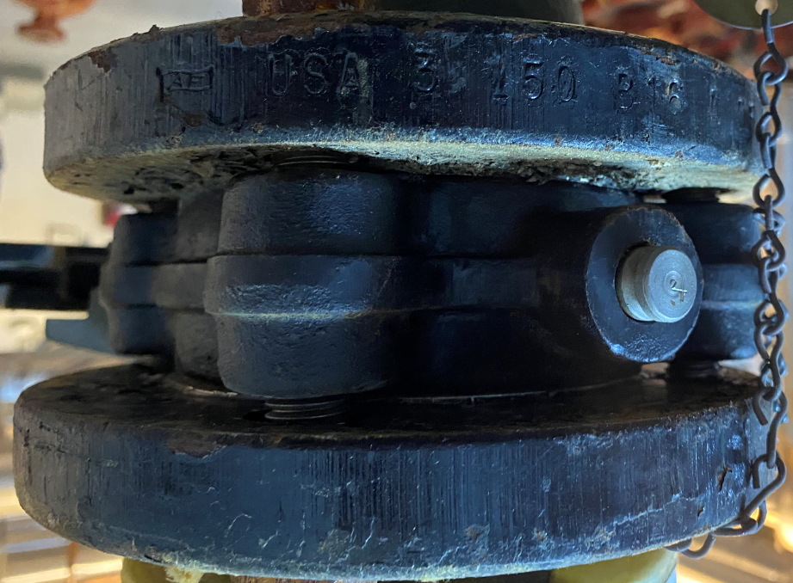

* **Q: Principal diagram?**

A: Kindly find in below the principal diagram:

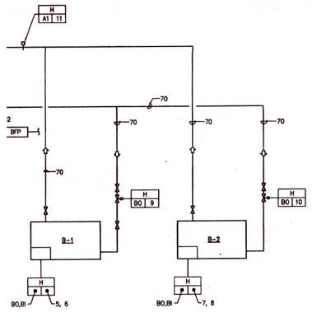

* **Q: Exhaust flue diameter and length?**

A: The diameter is 150mm. The length of the chimney exhaust flues is 4.40m starting from the roof ground.

* **Q: Add a new exhaust condensate drain on the exhaust flue of the second boiler (as per the 1st boiler)?**

A: Yes, to be added by the contractor exactly like in the 1st boiler exhaust flue.

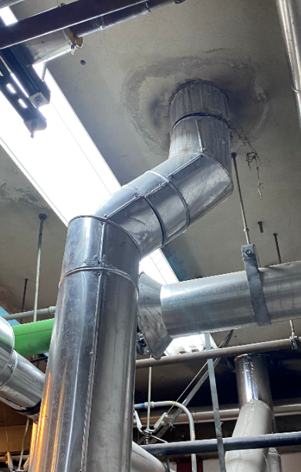  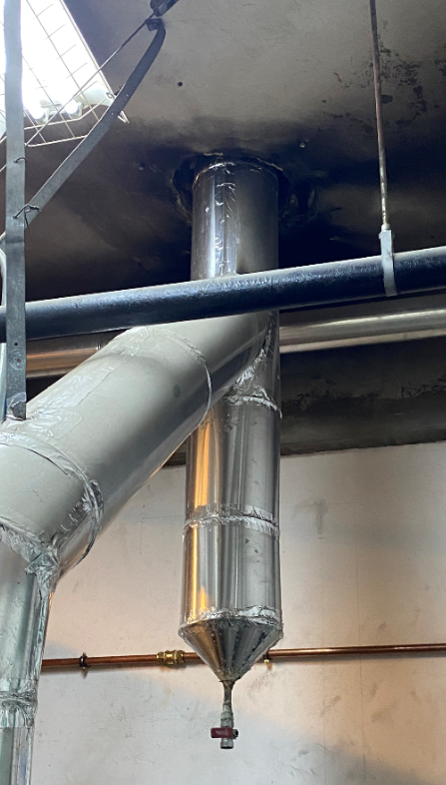

* **Q: Nameplate of the old boilers?**

A: Kindly find in below the nameplate of the old boilers

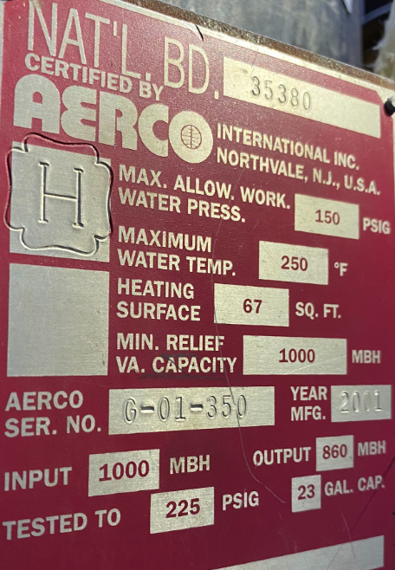

* **Q: Boilers power supply?**

A: Power supply: 230V

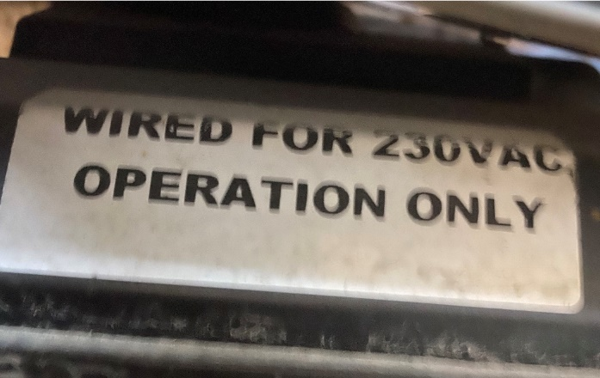  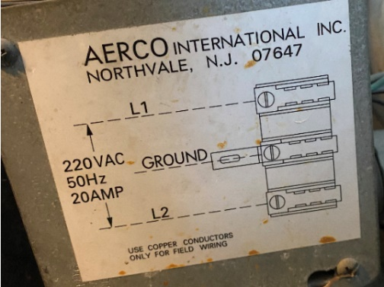

* **Q: BAS integration module?**

A: BACNET protocol