Leaders for Democracy Fellowship Program
Applicant Requirements and Preferred Fellow Profiles
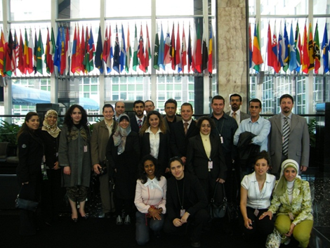
LDF Fellow Requirements
The program is open to applicants between the ages of 25 and 35 with a minimum of a bachelor's degree, with at least five years of professional work experience and sufficient English or Arabic language fluency to successfully function in an American or Arabic language university and professional working environment, as participants will need to discuss complex political and global issues with peers and experts.

With at least five years of professional work experience, the applicant should have both the capacity and the commitment to apply the experience gained through the Fellowship in improving their civic activities in their organization, specific community and/or sector in their home countries.

Preference for the US-based program should be given to applicants with relevant professional achievements who have not previously visited the United States.

Sample Fellow Profile Matches for the LDF Program
- Lamia is a civic activist from Iraq. She has a bachelor’s degree in international affairs and diplomacy and is currently pursuing a degree in international law. Lamia wants to promote women’s rights in her country and therefore has created a group of civic activist women volunteers who go to rural areas and teach women how to sell their homemade goods. Lamia and her group of activists have also created a website to sell these homemade goods online.
- Mohammed is a civic activist from Syria. He and his family moved to Lebanon after the Syrian war started. Mohammad has a BA in political science and an extensive experience working with NGOs in Syria. Mohammad wants to improve the lives of Syrians in Lebanon and specifically the Syrian youth. Thus, he volunteered with several civil society organizations and implement projects that help Syrians in Lebanon. Mohammed currently works with UNDP and believes that the best way to empower the Syrian Youth is through education.

Positive Fellow Characteristics for the LDF Program
LDF seeks candidates with excellent interpersonal and communication skills, proven leadership abilities, the ability to work in a cross-cultural setting and a commitment to the program and follow-on activities. Some additional characteristics that are a good match for this program include:

- Motivated
- Committed
- Self-driven
- Open-minded
- Flexible
- Curious
- Tolerant of diversity
- Collaborative attitude

Professional Background Matches for the LDF Program
Fellows selected should come from diverse professional backgrounds, organizations, and political orientations. Examples of professional backgrounds that are a good match for this program include:

- Civic engagement, education, advocacy and/or activism
- Human rights or human rights law
- Youth/female/persons with disabilities empowerment and engagement
- Media or journalism
- Humanitarian aid or refugee assistance
- Politics, campaigning, governance or electoral systems
- Foreign policy research

