EMBASSY OF THE
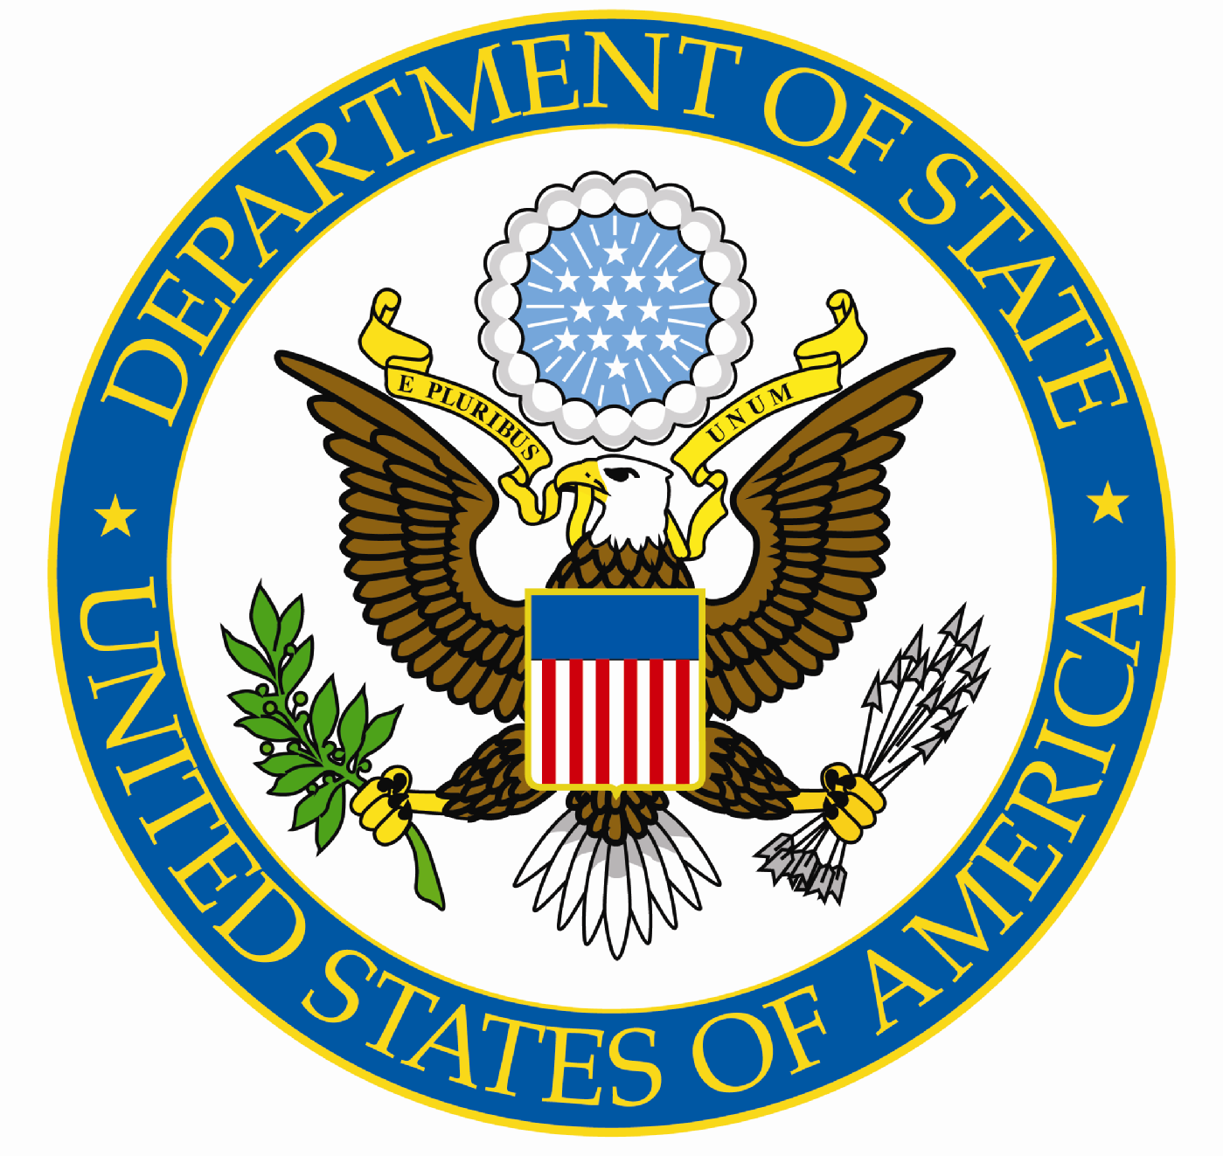
UNITED STATES OF AMERICA

Republic of Palau
Telephone: 587-2920/2990
Fax: 587-2911

For Immediate Release August 26, 2022

MEDIA NOTE

Resumption of Consular Services

On Tuesday, September 6, the U.S. Embassy will resume normal business hours for Consular Services. Consular Services will be available by appointment on Tuesdays from 9:00am to 11:00am and Thursdays from 9:00am to 11:00am.

For appointments, call (680) 587-2920 ext. 2900

