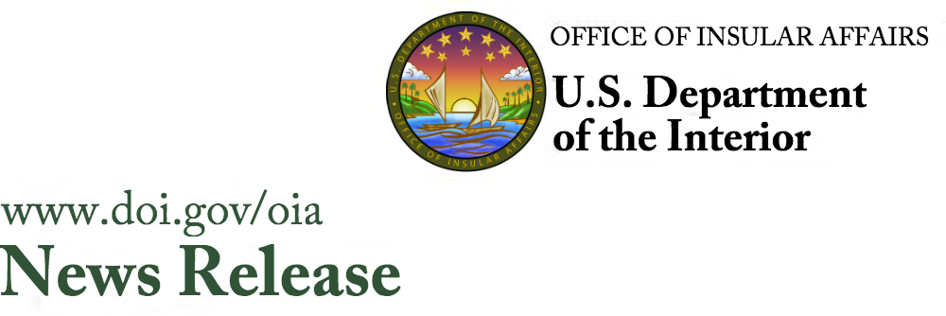
June 18, 2018
Contact: Tanya Harris Joshua 202-208-6008
Tanya_Joshua@ios.doi.gov

Office of the Assistant Secretary
Insular and International Affairs

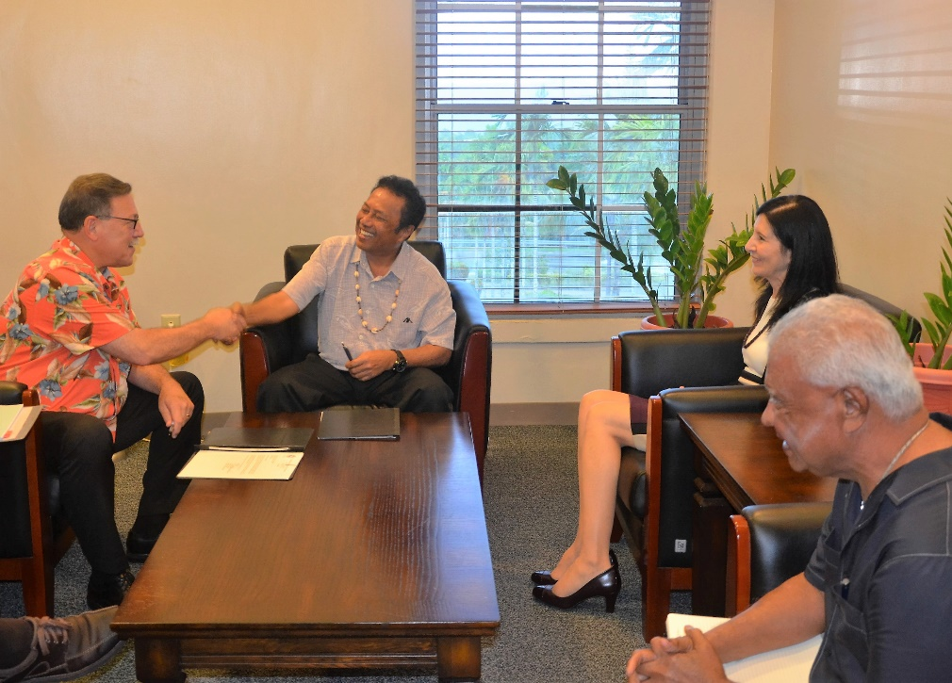
(l.tor. Assistant. Secretary Domenech, President Remengesau, Ambassador Hyatt, Finance Minister Sadang)

Interior Assistant Secretary Domenech Visits
Palau’s President Remengesau
Delivers Funds to Upgrade Ministry of Finance from
Microfiche to Digital Record Keeping

PALAU –Assistant Secretary of the Interior for Insular and International Affairs Doug Domenech joined by U.S. Ambassador to Palau Amy Hyatt, and Office of Insular Affairs Director Nik Pula today met with Palau President Tommy E. Remengesau, launching his official visit to Palau. During their meeting the Assistant Secretary signed over a technical assistance grant for $323,333, an amount requested by the Government of Palau to upgrade record-keeping and management systems for treasury, customs, personnel, and budget operations in the Palau Government.

“Interior Secretary Ryan Zinke and I are pleased to provide Palau with this technical assistance grant towards improvement of finance operations for the Government of Palau,” said Assistant Secretary Domenech. It is long overdue to facilitate Palau’s move from antiquated micro-fiche records to digital recordkeeping and archiving.”

“President Tommy E. Remengesau and I are grateful for this technical assistance grant from the U.S. Government, which is sure to significantly improve the national government’s recordkeeping system,” said Palau Finance Minister Elbuchel Sadang. “This project will not only help our government in addressing its digitization and public accessibility needs, but the system upgrade will also certainly improve the Ministry of Finance’s document reproduction quality. Additionally, it will allow new features of digital media, including indexing, that will allow more efficient retrieval and search capabilities,” Minister Sadang continued.

Funding will be used to procure a new document archiving system with new hardware and software, and an option to outsource archiving of historical data. System acquisition, including on-site installation and training, is expected to take six months and full-system utilization is anticipated next year. Funding was provided through the Office of Insular Affairs’ Technical Assistance Program.

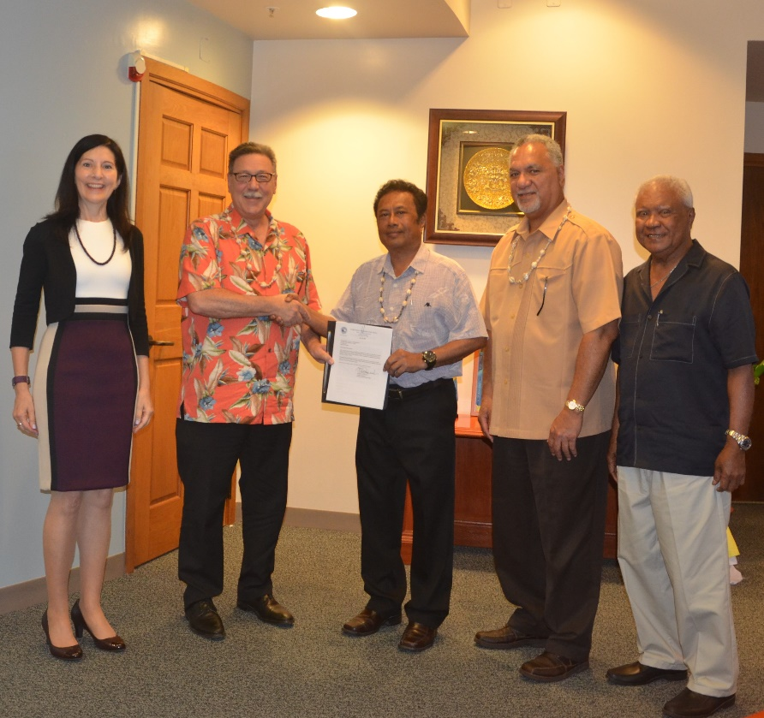
(l.tor. U.S. Ambassador to Palau Hyatt, Interior Assistant Secretary Domenech, Palau President Remengesau, OIA Director Pula, Palau Finance Minister Sadang)

The Assistant Secretary, Insular and International Affairs, and the Office of Insular Affairs carry out the Secretary of the Interior’s responsibilities for the U.S. territories of Guam, American Samoa, the U.S. Virgin Islands, and the Commonwealth of the Northern Mariana Islands. Additionally, OIA administers and oversees Federal assistance under the Compacts of Free Association to the Federated States of Micronesia, the Republic of the Marshall Islands, and the Republic of Palau. OIA supports the Secretary's mission of Fulfilling Trust and Insular Responsibilities through balancing efforts and limited resources towards stronger economic and health capacities, and fiscal accountability in the U.S. insular areas.

###

