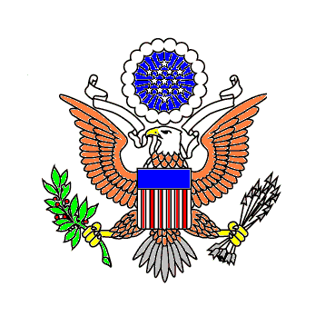

Embassy of the United States of America
Khartoum, Sudan

Date: July 20, 2022
Dear Prospective Vendors

Subject: Request for Quotations PR10941212

Enclosed is a Request for Quotations (RFQ) for hire a contractor to carry out all the necessary work required to renovate the RSO section on the second floor of the NOB. If you would like to submit a quotation, complete the required portions of the attached document, and submit it to the following address:

U.S Embassy, Contracting Officer
Soba Kilo 10 Block 88, Khartoum, Sudan

Please submit your quotation in a sealed envelope marked "Quotation Enclosed" to the above address. The deadline for receipt of quotations is Aug.03, 2022 at 13:00 local time, no quotations will be accepted after this time.
If you would like to attend the site schedule on July 27, 2022, at 10:00 am local time, please send your information to alashgerya@state.gov on July 25,2022 to arrange for access request

In order for a quotation to be considered, you must also complete and submit the following:
SF-1449 (block 17, 24 and 30) Block 24 should list the total value of the quote.

For more information, please visit the website https://sd.usembassy.gov/embassy/khartoum/contract-opportunities/?_ga=2.114822338.492638851.1614139678-633302068.1612350432

