FULBRIGHT VISITING SCHOLAR PROGRAM
Instructions for Completing the
2022-2023 Fulbright Visiting Scholar Program Application

Application: https://apply.iie.org/fvsp2022
Read all instructions carefully before completing the application. Applicants may only apply for one award per application cycle.

Contents
General Information 2
Creating Your Online Account 3
Managing Your Application 5
Preliminary Questions 5
Country Information 7
Data Privacy 7
Personal Information 7
Contact Information 8
Academic & Professional Information 10
Language Skills 16
Plagiarism Agreement 17
Project Proposal 18
Grant and Travel Plans 20
Additional Information 21
Recommendations 21
Signature 23
Review 24

General Information
The application is supported by all modern browsers. We highly recommend that you use a current version of Google Chrome, which supports Windows, Mac, and Linux platforms.

Prior to starting an application, please complete the following steps:
Step 1: Learn requirements for submitting an application
Before you begin an application, contact the Fulbright Program Office in the country from which you are applying. Deadline dates and application requirements for a Fulbright grant will vary from country to country. You must make sure you are eligible to apply. Additional information and a list of participating countries can be found here: https://www.cies.org/.

Step 2: Record user name and password in a safe place
Your email address is your user name. When you create an account for this online application, record your password in a secure place. You can log in and out of the application as frequently as you like using your user name and password. If necessary, you can reset your password by clicking the “Forgot Your Password” link on the log-in page.

Step 3: Complete the application
You do not need to complete this application at one time. You can re-enter at any time to edit your application. However, once you SUBMIT your application, you CANNOT make changes to it.

To complete your application correctly, please answer all questions completely and carefully. Review these additional tips:
- Use upper and lower-case letters (e.g. John Smith). Avoid using all capital letters (e.g. JOHN SMITH). Do not use special characters, such as accent marks.
- You can copy and paste information into all text boxes.
- Limit your responses to the space provided in all text boxes.
- Prepare required documents and save them in PDF format. It is highly recommended that to preserve any formatting and special characters in your documents, you upload them in PDF format.
- Some questions are “required.” They are marked with an asterisk (*). You will not be able to submit your application until all required items are complete.

Step 4: Submit the application
Once you have entered all required information, including recommenders, review your application for errors. If all information is correct, submit your application. Once you submit you CANNOT make changes to your application.

Creating Your Online Account

- To start, click Create an account.

- Enter your email address, first name, last name, and select your date of birth (Month-Date-Year) from the drop-down menus. Your name must be entered exactly the way it appears (or will appear) on your passport.

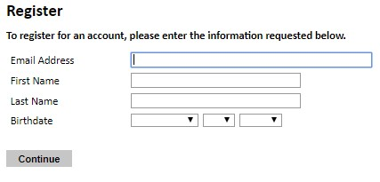

Note: Use an email address that you will be able to access for at least two years after submitting your application. This is the email address you will use to log in to your application account. We recommend you do NOT use a work email address if you will not have access to it during your grant in the U.S.

- Click Continue. You will receive an email from apply@iie.org confirming that you have started the application. The email will include a temporary PIN. Follow the instructions in the email to activate your account using the temporary PIN.

- You will be prompted to enter your pin and then create a password to complete login.

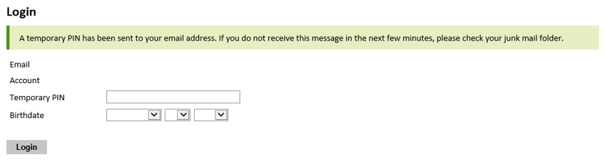

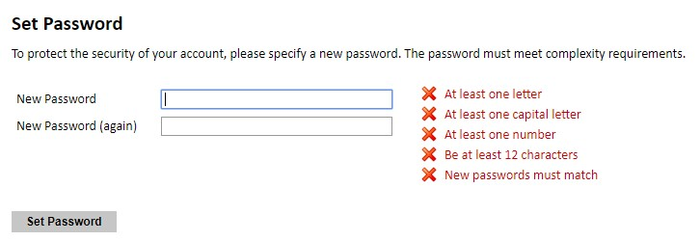
- Returning users: Click Log in and enter your email address and password. If you do not remember your password, click Forgot your password? and follow the resulting instructions.

Managing Your Application

EDITING YOUR APPLICATION PRIOR TO SUBMISSION

- You may log in at any time to review and edit your application form, upload documents, and enter recommender information.
- Remember to save your application after completing each page by pressing the Continue button at the bottom of each page.
Note: The application will automatically log you out after 60 minutes of inactivity, so it is best to save your application frequently.

REVIEWING YOUR APPLICATION AFTER SUBMISSION
- After you SUBMIT your application, you CANNOT make any changes.
- You may continue to log in to your account to view the information you have submitted, save a PDF of your application form, and manage your recommenders.
- You can manage your recommenders by clicking on the Recommendations section of the online application.

LETTERS OF RECOMMENDATION
Letters of recommendation will be submitted directly to Fulbright by the recommenders you registered via your application.
- Letters of recommendation and language evaluations may be submitted before or after you submit the application.
- If your recommender is unavailable, you will have the option to exclude the recommender and add an alternative after you submit the application.

Preliminary Questions

These questions address essential program eligibility. All questions are required.

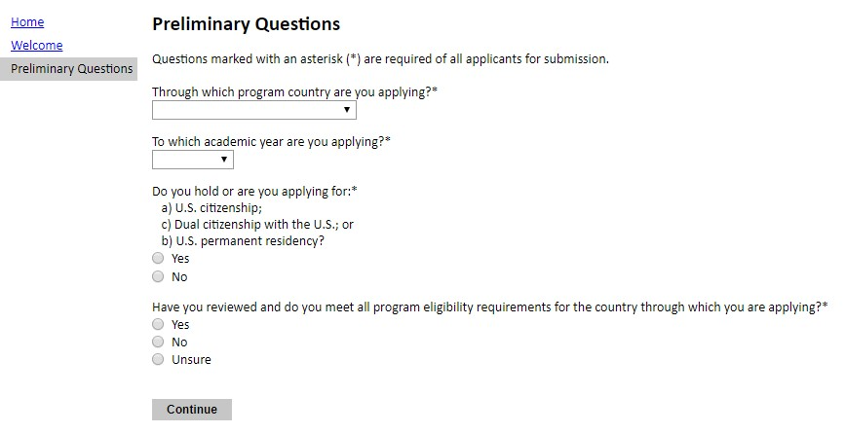

- Select the country through which you are applying for the Fulbright grant from the dropdown menu.

- Select the appropriate program year from the dropdown menu.

- U.S. Citizenship, Dual Citizenship with the U.S. or Permanent Residency: select ‘yes’ or ‘no’ to indicate your response.

  - Applicants cannot be U.S. citizens or permanent residents of the U.S. to participate in the Fulbright Visiting Scholar Program.

- Select ‘yes’, ‘no’, or ‘unsure’ to indicate if you are aware and meet all program eligibility requirements.
  - Please review the program eligibility requirements for the country through which you are applying before proceeding.

- Click Continue to save your responses and advance to the next section.

Data Privacy
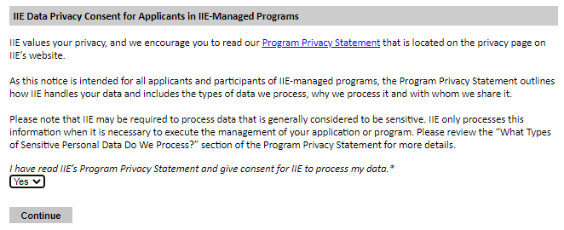
- Carefully review the Data Privacy information. If prompted, indicate your acceptance of data privacy terms by selecting ‘yes’ or ‘no’.

- Click Continue to proceed to the next section

Country Information

- Review all information in this section!

- Note any country-specific and award-specific instructions for completing the rest of the application, including:

  - Country website
  - Deadline information
  - Open application cycle
  - Additional required materials
  - Country-specific Fulbright Policies

If prompted, you must select an Award before proceeding.

- Click Continue to proceed to the next section

Personal Information

Enter all required biographical information. Please review country-specific guidance (provided in the Country Information section of the application) to determine whether you must provide additional information.

- Name: Enter your name exactly as it appears on your passport. Only enter a preferred name if it is DIFFERENT than your legal name (e.g. Alex instead of Alexander).

- Name on Previous Records: If your name is recorded differently on any previous records, list it in the Name on Previous Records section (e.g. maiden name).

- Biographical Information: The birthdate that you used to create your account will automatically appear. Enter your city of birth, country of birth, sex (as it appears or will appear on your passport or travel document), preferred gender identity, marital status, and number of dependents.

- Citizenship Information: Select your country of citizenship and country of residence from the dropdown menus provided.

  - If applicable, enter your national identification number and any additional countries in which you hold citizenship.
  - To select multiple countries, hold down the CTRL (PC) or Command (Mac) button when selecting options.

- Click Continue to save your responses and advance to the next section.

Contact Information

Enter all required contact information. Please review country-specific guidance to determine whether you must provide additional information

- Address: Select the country where you live from the dropdown list first when entering your permanent address (i.e. physical address where you live).
  - Based on your country selection, the subsequent fields will change to match the address format of that country.
  - Complete the remaining address fields. Do not use accents or special characters.
  - Select ‘yes’ or ‘no’ to indicate if your current mailing address (i.e. the address where you receive mail) is the same as the permanent address you entered above. They do not have to be the same.
    - If you answer ‘no,’ then a second address section will appear where you may enter your mailing address information.
    - If you answer ‘yes’ to this question, proceed immediately to the next section.

- Telephone Numbers: Enter your contact phone numbers as appropriate. Include the country code. If the field turns red, please review the numbers that you have entered to look for any errors. To find the correct country code, click on the blue ‘country code’ link

- Email: The email address used to create your account will appear in the primary email address field and will not be editable. You may provide an Alternate/Secondary Email that can be used to contact you if Fulbright Program officers cannot reach you via your primary email address. Note: All system-generated emails will continue to go to your primary email address.

- Emergency Contact Information: Entering emergency contact information is not required unless directed by the country-specific instructions. If you would like to provide emergency contacts in your home country, please enter the appropriate information. The individuals you list may be contacted in the event of an emergency while you are participating in grant activities, including any required travel for interviews in your home country. You may also enter emergency contact information for individuals in the United States.
  - When entering the address, choose the country that corresponds to your emergency contacts’ address first and the following fields will update to match the address format of the selected country.

- Click Continue to save your responses and advance to the next section

Academic & Professional Information

This section collects information about your academic and professional background, including your curriculum vitae/resumé, academic degrees, professional experience, organizational memberships, letter of support from home institution, experience abroad, and previous Fulbright grants, if applicable.

Prepare and upload documents in PDF format as required (*). Note any page limits and ensure your documents do not exceed page limits.

- Curriculum Vitae/Resume: Upload your curriculum vitae/resumé in PDF format that does not exceed six (6) pages.
Note: If your file exceeds 6 pages, an error message will appear on the Review page and will prevent submission of your application.

  - Click Browse
  - Locate and select the file that you previously saved to your computer c. Click Open
d. Click Upload to complete the file upload

- Academic Background: List all post-secondary educational institutions from which you have received a degree or academic credential in reverse chronological order. You MUST include any education institutions you are currently attending (even if you have not yet completed your educational program) and estimated date of graduation/completion.

  - Click Add Institution
  - Type in the name of the institution
  - Choose the level of study (graduate or undergraduate) from the dropdown menu
  - Select the country where the institution is located from the dropdown menu
  - Enter the appropriate city and region/state
  - Provide the website of the institution (optional)
  - Select the U.S. equivalent of the degree or diploma earned (e.g., BA – bachelor’s degree)
  - If relevant, provide the actual name of the degree or diploma (e.g., license)
  - Enter the discipline in which this degree or diploma was earned
  - Select the month and year of the date this degree was received (Month – Year format) from the drop-down menu
    - If a degree is in progress, list expected date of conferral for Date Degree Received.
  - Click Save.

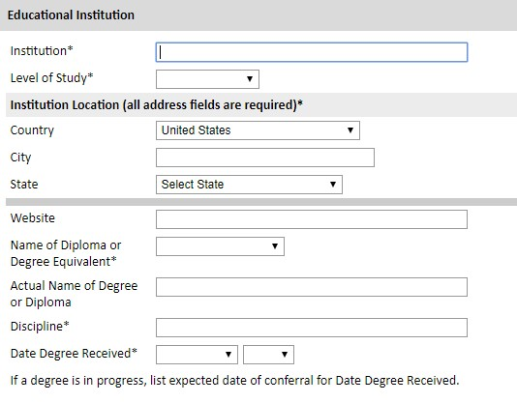

- To add additional entries for post-secondary educational institutions, click Add Institution and follow the bulleted instructions above.

- Current Professional Profile: List your current professional affiliation or employer by clicking Add Experience under Position Title

  - Choose the role which most closely corresponds to your current role from the dropdown menu
  - If you are an independent/unaffiliated scholar, check the box underneath the Current Role field. The Institution Name and Department Name fields will disappear after the box is checked
  - Enter your current position title (e.g. Professor, Assistant Professor, etc.)
  - Enter the name of the institution and, if relevant, the department where you are currently employed
  - Enter the start and end dates for the position you entered (Month-Year format). If you are currently employed in this role, leave the End Date fields blank.
  - Select the country where your current place of employment is located from the dropdown menu. Enter in the street address, city, state/region, and post code as applicable
  - Click Save

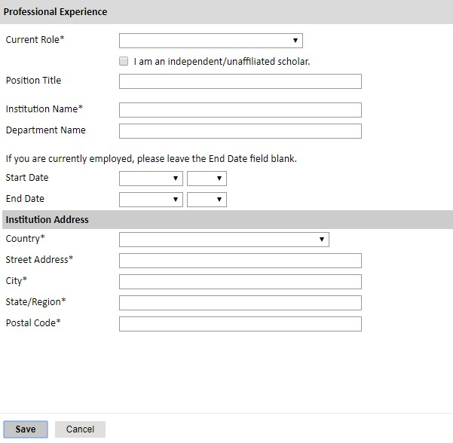

- If you have more than one current position, click Add Experience and follow the instructions above.

- List your most significant professional accomplishments, honors and awards, and up to three significant publications in the text box.

  - List no more than five accomplishments, honors, or awards
  - Separate each entry with a semicolon (;)
  - 700-character limit

- Organizational Memberships: List up to four professional memberships in cultural, educational, and professional organizations.

  - Click Add Organization
  - Enter the name of the organization
  - If you held an elective office in the organization, enter the name of your role (e.g.,
Treasurer)
  - Enter the start and end dates (Month-Year format) that correspond with your membership in this organization.
    - If you are still an active member, leave the End Date blank. e. Click Save

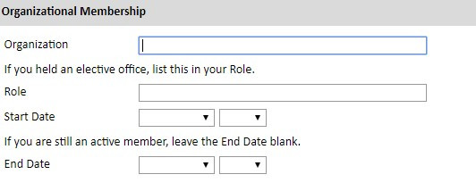

- Letter of Support from Home Institution: If required by your country-specific instructions, upload a PDF file of your letter of support/confirmation of leave from your home institution, confirming your ability to participate in a Fulbright award.

  - Click Browse
  - Locate and select the file that you previously saved to your computer
  - Click Open
d. Click Upload to complete the file upload

- Experience Abroad: List any professional travel and/or residence abroad that exceeds three (3) months, including any stays in the United States, during the last six years.
  - Click Add New
  - Select the country in which you spent your professional travel and/or residence abroad
from the dropdown menu provided
  - Select the start and end dates (Month-Year format) of you travel/residency
  - Enter the purpose of your travel abroad
  - Click Save

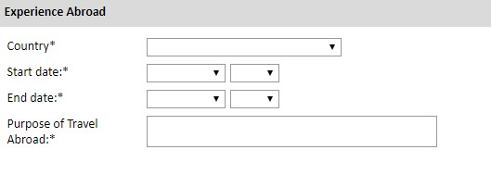

  - If you have more than one trip abroad to enter, click Add New again, and follow the bulleted instructions until all entries have been saved.

- Select ‘yes’ or ‘no’ to indicate if you have previously entered the United States on a J-1 or J-2 visa

• If ‘yes’, you are required to select the J category of sponsorship from the list and upload a copy of your previous DS-2019

*If you have participated in a J-1 or J-2 visa exchange program in the Professor or Research Scholar categories, please check with your Fulbright Office to confirm you are eligible to apply for the program at this time.

- Select ‘yes’ or ‘no’ to indicate if you have previously been awarded a Fulbright grant.
• If ‘yes’, you are required to list the grant(s):
    - Click Add Grant.
    - Select the Fulbright award type from the dropdown menu provided (e.g., Fulbright FLTA, Fulbright Foreign Student, etc.)
    - If you select “Other (please specify)”, enter in the name of the Fulbright grant that you received in the “Other, please specify” field
    - Select the academic year that corresponds to the year in which you received the
Fulbright grant.
    - Click Save

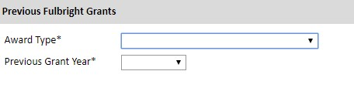

- If you are applying for another Fulbright Scholar Opportunity, please provide justification as to why you should be considered for another award in the text box.

- Click Continue to save your responses and advance to the next section

Language Skills

This section collects information about your native language, English language skills, and any additional languages that are relevant to your project proposal.

- Native Language: Select your native language from the dropdown menu provided.

- English Language Proficiency: If your native language is not English, a section collecting your English language proficiency will appear.

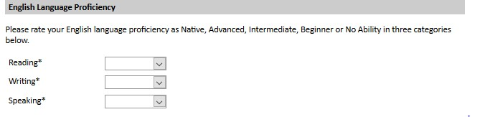

  - Rate your English language proficiency in Reading, Writing, and Speaking. Select Native, Advanced, Intermediate, Beginner or No Ability from the dropdown menus as appropriate.

- Additional Language Skills: Select the number of additional languages that you would like to include that may be of use for your project or study plans.

  - Select the language you are reporting from the dropdown menu and rate your proficiency in Reading, Writing, and Speaking. Select Native, Advanced, Intermediate, Beginner or No Ability from the dropdown menus as appropriate.

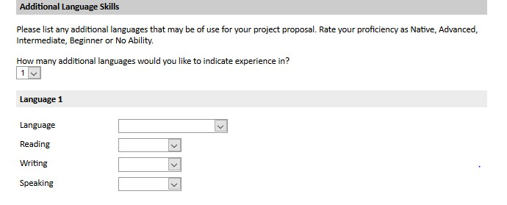

Plagiarism Agreement

- Carefully review the Plagiarism Agreement and indicate your acceptance of the terms by selecting ‘Yes’ or ‘No’.
Plagiarism in any part of your application will result in your disqualification from participating in the Fulbright Visiting Scholar Program.

Plagiarism will be understood to include any of the following:

Presenting wording, statistics or concepts as your own which should be attributed to someone else or to publications (online or offline). This includes, but is not limited to:
  - Copying the exact wording of a written source
  - Presenting material with alterations in wording
  - Paraphrasing the content of a source without citation
It is expected that your responses to all questions in the following application will be your own work and writing, with clear citation of secondary sources if describing academic work and the writing of others (including one's own previously published work). Any sources used in the construction of your responses must be clearly cited.
- Click Continue to save your responses and advance to the next section.

- Click Continue to save your responses and advance to the next section

Project Proposal

This section collects information about your proposed project. Please carefully review country-specific guidance to determine if you must submit any additional documentation.

- Select the category of grant for which you are applying.
  - If you select Research, you must upload a Bibliography
  - If you select Teaching/Research, you must upload a Bibliography and Course Syllabus
  - If you select Teaching, you must upload a Course Syllabus

- Project Statement: Enter your Project Title in the Project Title field. The project title must be in English. Make sure it is written in AP style: no abbreviations, not all caps; all words of four or more letters should be capitalized, no Oxford commas.

- Brief Summary of Project Proposal: Enter a summary of your Project Proposal in the text box (maximum of 700 characters)

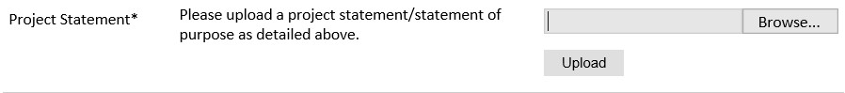
- Project Statement Uploader: Upload a detailed project statement of three (3) to five (5) pages in PDF format

  - Click Browse
  - Locate and select the file that you previously saved to your computer c. Click Open
d. Click Upload to complete the file upload

- Bibliography: If you selected Research or Teaching/Research category of grant, you will be prompted and required to upload a Bibliography of one (1) to three (3) pages of references relevant to the proposed research in PDF format following the instructions above.

- Course Syllabi: If you selected Teaching/Research or Teaching category of grant, you will be prompted and required to upload Course Syllabi of up to ten (10) pages for courses you either propose to teach or have taught in PDF format following the instructions above.

- Academic Discipline:

  - Select the most appropriate major academic discipline for your project from the dropdown menu.
  - Select the most appropriate primary specialization from the dropdown menu.
  - Enter a brief description of the area of the field in which you plan to specialize/conduct research in the United States in the text box.
    - Some fields (for example, Arts) will ask you if you’d like to upload portfolio materials as part of your application. Select ‘yes’ or ‘no’
    - If you select ‘yes,’ you will be directed to upload your materials on the next page.
Please follow the upload instructions listed.
- Intended Grant Period:
  - Select your proposed grant length (in months) from the dropdown menu
  - Enter your proposed grant start and end dates (Month-Day-Year format)

- Host Institutional Affiliation: Indicate whether you have already made affiliation arrangements with a U.S. Host Institution by selecting ‘yes’ or ‘no’

  - If ‘yes’, add the Host Institution by clicking Add Institution
    - Enter Institution Name
    - Enter Name and Contact Information of the person at the Institution who will be your primary contact
    - Enter the address of the Institution
    - Indicate whether you have received a letter of invitation
    - Click Save
    - Upload the Letter of Invitation (if available) by clicking Browse, locate and select the file from your computer, click Open and click Upload

  - If ‘no’, and you are not required to arrange an affiliation before applying, list any host institution preferences in order of priority by selecting Add Institution
    - Enter Institution Name
    - Enter Name and Contact Information of the person at the Institution who you have communicated with previously, OR the main contact for the department that you are interested in joining
    - Enter the address of the Institution
    - If you are in contact with the Institution, enter the date (Month-Day-Year form) of your initial contact
    - Enter a reason for the suggested affiliation
    - Click Save

- Alternate Awards: If the country you are applying through allows you to opt in to consideration for other awards offered through their country (refer to the Country Information Page for information), select “yes” and indicate those award names in the box provided.

- Click Continue to save your responses and advance to the next section

Grant and Travel Plans

This section gathers information on your personal finances, additional grants you may have applied to/received, passport, and accompanying dependents. Please note that these sections may not be required if you are from certain countries. Review country-specific information before completing.

1. Financial Information: Select ‘yes’ or ‘no’ to indicate if you have other sources of financial support during your Fulbright grant

- If ‘yes’, select the number of other sources of funding you expect to receive
  - Enter Source Description (e.g., NSF grant)
  - Estimated Amount (in U.S. dollars)
  - The Other Funds Total field will automatically update based on the amounts provided above
  - Financial Support Documentation: Once you enter a number for additional sources of funding expected, upload supporting documentation by selecting Browse, select the relevant file and click Upload.

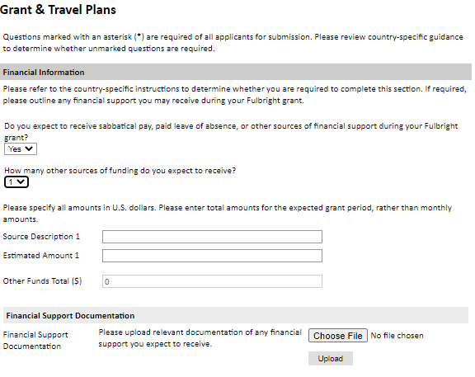
- Additional Grants: Indicate if you are planning to apply for other sources of funding to supplement the Fulbright grant award in the text box (1000-character limit). Include the course and amount for all funding.

- Passport/Travel Document: If required by your country-specific instructions, upload a copy of your passport or travel document by selecting Browse
- Accompanying Dependents: If required by your country-specific instructions, select the number of dependents you intend to have accompany you in the U.S. (select 0 if you do not have dependents or your dependents will not accompany you the U.S.)

a. If you select 1 or more, you will be prompted to enter required information for each dependent, including relationship to you, name, date of birth, sex, country of citizenship, previously held U.S. J-1 or J-2 visa, and intended length of stay in the U.S.

- Click Continue to save your responses and advance to the next section

Additional Information

- Additional Documentation: Use this section to upload any required additional documentation per your country-specific guidance.

- Outreach Survey: Complete the Outreach Survey.

- Click Continue to save your responses and advance to the next section

Recommendations

Use this section to register your recommenders. Refer to your country-specific instructions for details on the required number of recommenders.

Once you register your recommenders, they will receive an automatic email with instructions on completing the online recommendation form. You can track the status of recommendations, send reminders, and add/delete recommenders through this system before and after submission of your application.

- Click Add Recommender
- Complete all fields in the pop-up form:

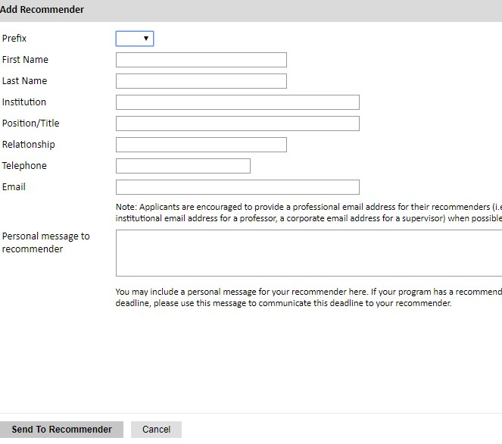
- Click Send to Recommender to generate automatic email to recommender
- Click Continue to save your responses and advance to the next section
- Once sent, you will have the option to Edit Recommender information if they have not yet started progress on their response and Save, Send Reminders, and Exclude if you wish to remove the recommender and replace with another individual.

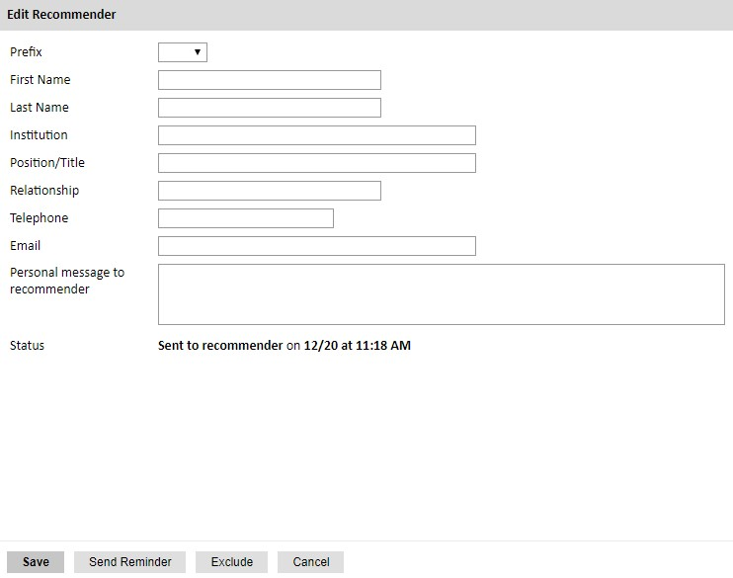

Signature

Certify that the information you provided in the application is true and complete by typing your full legal name in the Signature Box:

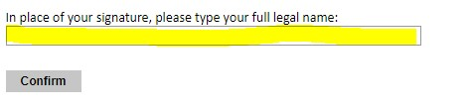

Click Confirm to continue to the next page.

Review

The application will review the responses entered and will display any incomplete questions and required attachments that are missing.
- If no errors appear, then your application is ready for submission.

- If any errors appear, correct or complete these sections and return to the Review section to determine if your application is ready for submission.

REVIEW ALL RESPONSES. CLICK SUBMIT.

